SAINT FRANCIS AND THE MISTERY OF MERCY
Saint Francis, as he recalls in his Testament, began his life of conversion with the experience of God's mercy. The main point of his new experience is mercy. A mercy received from God and, in his turn, used it for others. "The Lord gave to me, Brother Francis, thus to begin to do penance; When I was in sins, it seemed extremely bitter to me to look at lepers, and the Lord himself led me among them and I practiced mercy with them. And when I left them, that which had seemed to me bitter was changed for me into sweetness of body and soul. And afterwards I remained a little and I left the world" FF 110.
Francis is aware that "the Lord has given mercy," "the Lord himself led him to use mercy", it was all the Lord's mercy! He embraced the leper and kissed his hands. According to Prof. Onorato Grassi, St. Francis, in that first act of kissing the leper did an experience of a mother with her son. A mom kiss her son even though he is leper and Francis enters the same experience; The Mercy that Francis experienced here is not one simply compassion towards the leper, but a deep humanism, is the principle of regenerating the human! Embrace the leper means look at him with the eyes of God! Here St. Francis, alter Christi, already has the experience of the Economy of Salvation: "Make your own the mind of Christ Jesus: Who, being in the form of God, did not count equality with God something to be grasped. But he emptied himself, taking the form of a slave, becoming as human beings are; and being in every way like a human being, he was humbler yet, even to accepting death, death on a cross…” (Phil.2,5-8) Francis here begins to enter into the logic of Christ!
And who receives the mercy of God suddenly get hold of somebody. The conversion or penance, by Franciscan vision, is communication; it is understood not as a renunciation of the world, but as love to the world; Do penance is not to deprive of something in the world, not the separation from the world, but to embrace more of the world. That means, making possibility to give a human rebirth. St. Francis, therefore resolved in his heart never in the future to refuse any one, if at all possible, who asked for the love of God. This he most diligently did and carried out, until he sacrificed himself entirely and in every way; and thus he became first a practiser before he became a teacher of the evangelical counsel: To him who asks of thee, he said, give; and from him who would borrow of thee, do not turn away. It is the pure mercy and is the pure work of God!
Mercy is an exercise of giving and receiving! The contemplation of the mercy of the Lord when was involving St. Francis, he was feeling certain unspeakable joy and the surpassing sweetness was overflow his inmost heart FF 363.
The Franciscan Sources show us how Francis was the perfect mirror of Misericordiae vultus; Here mercy is understood, says Pope Francis in his encyclical: as the visceral experience of love of a mother for her son.
In the following texts we see some episodes that show the corporal and spiritual works of mercy exercised by Francis.

THE CORPORAL WORKS OF MERCY
1 - FEED THE HUNGRY
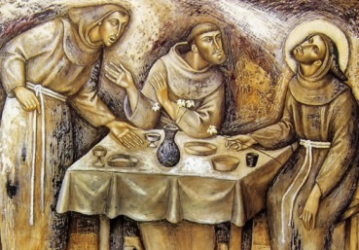
All Franciscans know the story of the friar who shouted in the day of fasting at night saying, "I'm dying, brothers, I’m dying of hunger", and St. Francis, not only has he started eating first, but called all the brothers to make the meal with him, so that, over the hungry, that brother would not feel the shame. In order to the brothers use mercy towards him, St. Francis gives them this exhortation: "the mercy be an example, not the food, because, the first leads to spirit and the second leads to gluttony! "(FF 608; 1549).
2 - GIVE DRINK TO THE THIRSTY
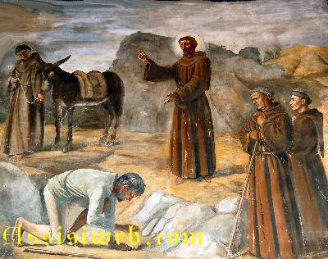
How not to remember the Francis causes a spring of water to flow from a rock for a thirsty man accompanying him during his trip to La Verna in the year 1224. Since St. Francis was weak he rode on a donkey belonging to a certain poor man. Worn out from the journey and weakened by a burning thirst he began to cry out after the saint, "I'll die of thirst if I don't get a drink immediately!" Without delay St. Francis leaped down from the donkey, knelt on the ground, raised his hands to heaven and prayed unceasingly until he understood that he had been heard. After he had finished his prayer, he told the man, "Hurry over there to the rock and you will find living water where at this hour Christ has mercifully brought forth water from the rock for you to drink." (FF632; FiorCons 46-50 1st).
3 - CLOTHE THE NAKED
As well as before his conversion, St. Francis had certain sympathy toward the poor people. One day he met a poor knight who was of noble birth but poor and badly clothed. Moved by compassion, he took off his own garments and clothed the man on the spot. At one and the same time he fulfilled the two-fold duty of covering over the embarrassment of a noble knight and relieving the want of a poor human being. FF 585.
One winter day, comes a poor old woman begging. Francis, full of mercy and compassion, not having nothing else to give her, take off his neck scarf (which was not yet belong to him) saying her: "go on, woman, and make a dress for you, because you really need it." The old lady, marvellous, - or out of fear or out of joy - takes the cloth from his hands and runs faster, cut it immediately with scissors to avoid delaying it, has to have to return. But, soon recognized that the piece of cloth, it would not be enough to make a dress, so returned soon from St. Francis to expose her problem. St. Francis asked to his companion-friar even to give his own also, so that old woman can finish her dress, exhorting him to suffer, both of them, the cold for love of God. Hence, both were naked, to cover the old woman FF 673.
4 - SHELTER THE HOMELESS
Francis, both in the Rule and in his Testament reminds us that we always dwelling there as strangers and pilgrims (FF122)!
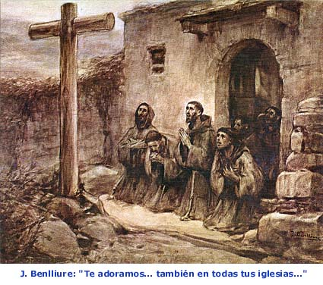
The cradle of our family, the Portiuncula, is a shelter borrowed for the Franciscans pilgrims! (FF1552). Once when they were in the Old Hut of Rivotorto, came a farmer with his donkey, and in order not to be driven away, he urged his ass to go in, saying these words, "Go in, for we shall do good to this place”. St. Francis hearing this soon abandoned that place He would have nothing in the way of property that the experience of mercy might more fully possess all things in the Lord (1Celano 44).
5 - VISIT THE SICK

From the beginning, Francis went among the lepers and lives with them, he became such a servant and friend of the lepers, that, as he testified in his Testament, he stayed among them and served them with humility.
He was washing their decomposing bodies and handles with the virulent plagues, as he himself recalls in his Testament. From that first kiss to the leper, after doing violence to himself, he decided to increasingly despise, by the mercy of the God, until gained complete victory (FF348). Besides, he willed that all the brethren of his Order, both when they were travelling about the world and when they were halting on their way, should serve the lepers for the love of Christ, who for our sake was willing to be treated as a leper.
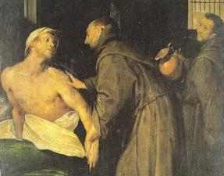
It happened once, there was a hospital for leprosy and other infirmities, served by his brethren; and there was a leper so impatient, so insupportable, and so insolent, that many believed of a certainty that he was possessed of the devil (as indeed he was) for he ill-treated with blows and words all those who served him; and, what was worse, he blasphemed so dreadfully our Blessed Lord and his most holy Mother the Blessed Virgin Mary, that none was found who could or would serve him. Wherefore they determined to abandon this leper, but this they would not do until they had signified their intention to St Francis, according to the Rule. On learning this, St Francis, who was not far distant, himself visited this perverse leper, and said to him: "May God give thee peace, my beloved brother!" To this the leper answered: "What peace can I look for from God, who has taken from me peace and every other blessing, and made me a putrid and disgusting object?" St Francis answered: "My son, be patient; for the infirmities of the body are given by God in this world for the salvation of the soul in the next; there is great merit in them when they are patiently endured." The sick man answered: "How can I bear patiently the pain which afflicts me night and day? For not only am I greatly afflicted by my infirmity, but the friars thou hast sent to serve me make it even worse, for they do not serve me as they ought."
Then St Francis began to pray, interceding most earnestly for him. Having finished his prayer, he returned to the leper and said to him: "My son, I myself will serve thee, seeing you are not satisfied with the others." "Willingly," answered the leper; "but what canst you do more than they have done?" "Whatsoever you wish I will do for thee," answered St Francis. "I desire then," said he, "that you wash me all over; for I am so disgusting that I cannot bear myself."
Then St Francis heated some water, putting there in many odoriferous herbs; he then undressed him, and began to wash him with his own hands, while another brother threw the water upon him, and, by a divine miracle, wherever St Francis touched him with his holy hands the leprosy disappeared, and his flesh was perfectly healed also. On this the leper, seeing his leprosy beginning to vanish, felt great sorrow and repentance for his sins, and began to weep bitterly. While his body was being purified externally of the leprosy through the cleansing of the water, so his soul internally was purified from sin by the washing of tears and repentance; and feeling himself completely healed both in his body and his soul, he humbly confessed his sins, crying out in a loud voice, with many tears… (Fioretti 25 FF 1857).
On another occasion, one of the friars, who was a spiritual man and an early member of the Order, was ill and very weak. As he looked at him, the St. Francis felt great compassion for him. But because at that time the friars, both healthy and sick, were cheerfully regarding their poverty as plenty, and would not use or ask for medicines in sickness, but willingly accepted bodily privations, St. Francis said to himself, 'If only this brother could eat some ripe grapes first thing in the morning, I think they would do him good.’ And he acted on this idea, for he rose very early one day, and calling the friar to him privately, led him into a vineyard near the friary. Choosing a vine where the grapes were good to eat, he sat down beside the vine with the brother, and began to eat the grapes lest the brother should be ashamed to eat alone. Compilation of Assis 53
Truly, St. Francis always wore on his heart that bundle of myrrh, always staring at the face of his Christ, always remained in contact with the Man of sorrows, who knows all the suffering! (FF 672).

6 - VISIT THE IMPRISONED

St. Francis still before his conversion, knew turn into joy the prison life with his friends and his joy and good humour was transporting his prison friends to the light of life. He himself, after the experience of San Damiano, being afraid of the persecution of his father, lives in a hidden pit for a month so continuously that, he dared hardly come forth for human need. When food was given him he ate it in the secrecy of the pit, and every service was rendered to him by stealth. 1Celano 10

7 - BURY THE DEAD

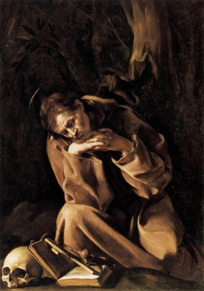
Francis had such an affinity with his sister death that not only contemplated holding the skull in his lifetime, and at the hour of his death, he hugged her greeting: "Hearty Welcome, my sister death!" (FF 809).
We are in the Jubilee Year of the Pardon of Assisi (1216-2016). The grace of the annual Pardon obtained by St. Francis for everyone "those present and those who will come till the end of the world" is not his desire to send everyone to Heaven? Is not it his bowels of mercy toward all?
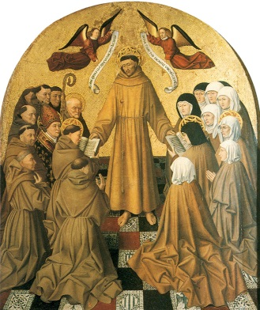
In the appearance of the Seraphic at Mount Verna, Francis receives the grace to go down to purgatory, every year, in the day of his death, and carry through him by the merit of his stigmata, all the souls of the three Orders, ie. Friars, Sisters and Continents, to the glory of heaven. "(3ªFiorCons). It shows his merciful love for the living and the dead!
Here, we are not imagine the logo of the Year of Mercy where Jesus and the man (over his shoulders) are sharing one eye. Christ sees with the eyes of Adam, and Adam with the eyes of Christ. St. Francis, really knew how to look at the world, the living and the dead, with the eyes of Christ, why he is the Alter Christi

Concluding, the encyclical of Pope Francis: "Laudato Síí – Praise be to You," once again, inviting us to fall in love with the "Canticle of the Creatures", because it shows the merciful heart of Francis: in order to give a human face to creation, making of every creature a brother or a sister: Brother Sun, Sister Moon, St. Francis knew how to use mercy to Mother Earth! It is worthy to recall here of the reflections of Father Cantalamessa in an interview with the Zenith:
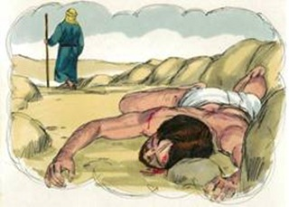
“It’s true, the earth today, in fact, is like that poor man assaulted by brigands and left half dead on the road. Many pass by him and go on, pretending not to see or simply leaving to others, who will come after them, to be concerned with the problem. It is necessary to find many “Good Samaritan” for our “Sister, Mother Earth.” Of course, there is another, more “human” relation between mercy and the care of Creation and it is that to have respect for Creation means to have mercy for those that will come after us, and not leave them without resources for a fitting life on earth. The seven works of corporal mercy must also be read for the future: to give to eat to one that one day is hungry, to drink to one that one day is thirsty …” (also Refr. FF 750-757).

THE SPIRITUAL WORKS OF MERCY
1 - COUNSEL THE DOUBTFUL
Francis knew how to give and receive good counsel: a short time after his conversion, St. Francis was much troubled and perplexed in mind thinking about what he ought to do: whether to give himself entirely to prayer, or now and then to preach the Word. Wishing to know the will of God, St. Francis sent Brother Masseo, to St Clare, and then to Brother Silvester. As he brought the same counsel from both: “it is his will he should go about the world to preach; for he has not been called for himself alone, but the salvation of others” Fioretti 16.
Once St. Francis and his brothers were going to Mount Alverne and when Francis could not walk any farther, they went and asked a peasant whether he would take Father Francis up to Mount Alverna on his donkey. "Francis of Assisi?" asked the peasant.
When they replied "Yes”, the peasant ran over to him and asked: . "Are you Francis of Assisi?" And when St. Francis responded: "I am”, the fellow counselled him: "Well then, take care to be as good as they say you are, because many people have put their trust in you. So I beg you never to do anything that will destroy our faith and hope!" Even though the Brothers were highly indignant, Francis kneeled down and kissed the peasant's feet, saying: "Thank you for this warning!" The first consideration.
2. INSTRUCT THE IGNORANT (CHILD)
A certain pure and innocent child was received into the Order during the lifetime of St Francis, and the convent in which he lived was so small that the monks were obliged to sleep on mats. It chanced that St Francis came one day to that convent, and in the evening, after Compline, he went to rest, so as to rise up early to pray, as was his custom, when all the other friars were still asleep. The said little child had made up his mind carefully to watch St Francis, to learn something of his sanctity, and find out more especially what he did in the night when he got up; and in order that he might not be overtaken by sleep, he laid him down by St Francis, tying the end of the cord he wore round his waist to the one which the saint wore, so that he was sure of being awakened when the latter got up in the night; and this he did so gently, that St Francis was not aware of his contrivance. When all the other friars were fast asleep, St Francis rose from sleep, and finding the child’s cord tied to his own, he carefully untied it so as not to awake him and went alone into the wood which was near the convent. Entering into a little cell which was there, he began to pray.
Shortly after, the child awoke, and finding St Francis gone, and the cord untied, he rose up quickly and went to seek him. Perceiving the door open which led to the wood, he thought St Francis had gone that way; and entering into the wood, and hurrying on to the little cell, he heard the sound of many voices. Approaching near to hear and see whence they came, he saw a great and wonderful light all round the saint, and in the light was Jesus Christ, with the Virgin Mary, St John the Baptist, St John the Evangelist, and a great multitude of angels, all talking with St Francis. On seeing this, the child fell to the ground as if he had been dead. The miracle of this holy vision being ended, St Francis rose to return to the convent, and stumbling in the way against the child, who appeared to be dead, with great compassion he took him up in his arms and carried him in his bosom, as the good shepherd is wont to carry his lambs. Having learned from him how he had seen the vision, he forbade him to tell any man thereof so long as he, St Francis, lived. The little child grew up in the grace of God, and had a great devotion to St Francis. He became one of the most distinguished men of the Order. After the death of St Francis, he related the vision to the brethren. Fioretti 17

When we read the following episode it seems that we are in front of two children who are joking:
Once St Francis was with Brother Leo and they hadn’t Breviary to say the Divine Office. So, when the hour of Matins arrived, St Francis said to Brother Leo: “My beloved brother, we have no Breviary where with to say Matins, but in order to profit the time in praising God, I will say, and you shall answer me as I will teach you; and beware to not change the words that I shall bid thee say. Thus St. Francis began: O Brother Francis, since have committed so many sins, you are worthy of hell.” And Brother Leo answered: “God will work so much good through thee, that you will not certainly go to heaven”. Do not speak thus, “Brother Leo,” said St Francis, you must answer: ‘Yes, indeed, you are worthy to be numbered among the cursed.’” And Brother Leo answered: “Most willingly, O my Father.” Then St Francis, with many tears and sighs, striking his breast, cried with a loud voice: “O Lord of heaven and earth, I have committed against thee so many sins and so great iniquities, that I deserve to be cursed by thee.” And Brother Leo answered: “O Brother Francis, among all the blessed the Lord will cause thee to be singularly blessed.” And St Francis reproved him saying: “Why you do not answer as I taught thee? I command thee, under holy obedience, so to do: When I say, ‘O wicked Brother Francis, do you think God will have mercy on thee, since you have so sinned against the Father of mercies that you are not worthy of finding mercy.’ But when St Francis began to repeat, “O wicked Brother Francis,” and so on, Brother Leo answered: “God the Father, whose mercy is infinitely greater than thy sin, will show great mercy upon thee, and will grant thee likewise many graces.”
At this answer St Francis, being meekly angry, and patiently impatient, said to Brother Leo: “How can you presume to act against obedience? Why do you have answered the contrary to what I ordered thee?” With great humility and respect Brother Leo answered: “God knows, my Father, that I had resolved in my heart each time to answer as you commanded me, but the Lord made me to speak as it pleased him, and not as it pleased me.”
Then St Francis, being greatly astonished, said to Brother Leo: “I entreat thee, beloved, this time to answer as I command thee.” And Brother Leo said: “Speak, in the name of God; for this time most certainly I will answer thee as you desire.” And St Francis, weeping, said: “O wicked Brother Francis, do you think that God will have mercy on thee?” And Brother Leo answered: “Not only will he have mercy on thee, but you will receive from him especial graces: he will exalt thee and glorify thee to all eternity, for he that humble himself shall be exalted; and I cannot speak otherwise, because it is God that speak by my lips.” After this in humble contest, they watched till morning in many tears and much spiritual consolation.

It is interesting that in this same episode we can see 12 times the word mercy.
3. ADMONISH THE SINNER
In the Letter to a Minister St. Francis reflects his mercy from maternal heart toward those who are in sin: "... And by this I wish to know if you love the Lord God and me, …if you have acted in this manner: that is, there should not be any brother in the world who has sinned, however much he may have possibly sinned, who, after he has looked into your eyes, would go away without having received your mercy, if he is looking for mercy. And if he were not to seek mercy, you should ask him if he wants mercy. And if he should sin thereafter a thousand times before your very eyes, love him more than me so that you may draw him back to the Lord. Always be merciful to brothers such as these” (Lmin).
St. Francis was very much distressed if he saw any poor man harshly spoken to, or if he heard any one utter a curse against any creature.
It happened that a brother had given a sharp answer to a poor man who had asked alms, saying, "See to it, for perhaps you are a rich man feigning poverty." When St. Francis, heard of it he was deeply grieved, and sharply rebuked the brother who had spoken thus, and bade him strip himself before the poor man, kiss his feet and beg his pardon. 2Celano 85.
How we can forget here the episode of the one who asked Francis humbly to join in to the Order. When this man, sought to be received into the Order, St. Francis answered him: “If you are fain to be joined unto the poor of Christ, part your goods among the poor of this world.” Hearing this, the man arose, and, led by carnal affection, bequeathed his goods unto his own family, and naught unto the poor. But when St. Francis heard of this from his own mouth, he scold him with admonition, “Go your way, brother fly, for you have not yet gone out of your from your kindred and from your father’s house. You have given your goods unto your family, and have cheated the poor, you are not meet for the holy poor. You have begun in the flesh, and have laid a shaking foundation for a spiritual edifice.” Then that carnal man returned unto his family, and sought again his goods, and was not minded to bequeath unto the poor; thus quickly he abandoned his virtuous intent. LM 7,3
4. COMFORT THE SORROWFUL

Francis, having a maternal heart to his friars, he could read the perturbed hearts, go to meet and treat them as a mother loves and nourishes her children RB 6.9.
Once, an elderly friar of the Order, a friend of St. Francis, being tortured for days by severe and cruel suggestions of the devil, appeared to sink into a deep despair. He harassed every day, and the more he was ashamed to confess every time. So he was punishing himself with abstinence, vigils, tears and beatings. St. Francis, reaching in that convent, as he strolled along with a brother and that poor troubled, away at some point from the first, approaching that friar tormented said: "Dearest brother, I recommend you that there is no need to confess those suggestions and raids of the devil; they did not do any harm to your soul. Whenever you are assailed, I suggest you to recite seven times the Lord's Prayer. Then that friar immediately was freed from all kinds of evil Mirror of Perfection 106.
A brother, very devoted, was brooding in the heart with the thinking: will be worthy of the grace of the sky one to whom Francis gives his familiarity and affection; But to him that is treated as an outsider, it must be considered excluded from the number of the elect. He was often tormented by this idea, wanting his familiarity, but not revealing to anyone the secret of his heart. But Francis called him softly and spoke thus: "Do not disturb you any thought, my son, because I will believe the most expensive among all those who are particularly dear to me and gladly I will make those of my familiarity and of my love" FF 1196
A brother named Ricerio, noble not only by birth but also by conduct have an eager desire to attain the favor of holy father Francis, but he greatly feared that in consequence of some hidden judgment St. Francis shrank from him and made him a stranger to the favor of his love. That brother considered that if St. Francis loved any one with the deepest charity, such a one would also be worthy to deserve God's favor, but that, on the other hand, any one to whom St. Francis did not show himself well disposed and benign would fall under the wrath of the judge on high. These thoughts the said brother kept turning over in his mind, of these things did he frequently hold silent converse with himself, disclosing the secret of his cogitation to none.
St. Francis, understanding his thoughts at once, said him, "Let no temptation mislead you my son; let no cogitation afflict you, for you are most dear to me, and know that among those specially dear to me you are worthy of my affection and intimacy. Come in to me confidently whenever you will, and let my friendship give you confidence to speak." Ricerio wondered with the utmost amazement, and thenceforward having become more reverent, as he increased in the holy father's favor, so he began to have a larger trust in God's mercy. LM 11,9.
It is notable that St. Francis how consulate his brother Lion: While St. Francis was sojourning on Mount Alverna, secluded in his cell, Frei Lion had mighty desire to possess some of the words of the Lord written by his hand, and with brief notes thereupon. For, having it, he believed that he might escape a grievous temptation, not of the flesh, but of the spirit. Even though he was pining with such a desire, did not dare to lay the matter before St. Francis. But the Spirit revealed him it and St. Francis asked him to bring unto him ink and parchment, and according unto the desire of the Brother he wrote with his own hand the praises of the Lord thereon, and finally, a blessing for him, saying: “Take unto thyself this parchment, and keep it with care until the day of thy death.” The Brother received the gift he had so desired, and forthwith that temptation utterly departed from him. LM 11,9
And in another one opportunity St. Francis told to Frei Lion: "So I say to you, my son, like a mother: all words that we exchanged along the way, to summarize briefly in this one sentence and advice even if after you will need to return from me to advise you - for so I suggest: in whatever way seems best to please the Lord God and to follow in his footsteps and his poverty, do so with the blessing of the Lord God and my obedience. And if it is necessary for the good of your soul, to get consolation, and you want to, or Lion, come to me, come! " FF 250.

5. BEAR WRONGS PATIENTLY

Francis knew forgive and offer forgiveness to those who offended. Celano tells us that once, when St. Francis was returning from beyond sea, with Brother Leonard of Assisi as his companion, it chanced that, worn out and weary as he was, he was riding on an ass. His companion, as he followed him,—himself no little wearied,—began to say within himself, with a touch of human weakness: “This man’s family was not of equal standing with mine own. And now, look you, he rides, and I on foot lead his ass.” Even as he thus reasoned, St. Francis forthwith dismounted from the ass, saying : “It is not fitting. Brother, that I should ride, and you walk afoot, for that in the world you were of noble birth and more standing than I.” Then the Brother was dumb with amazement, and blushed for shame, and, perceiving his fault, fell at the other’s feet, which he bedewed with tears, and laid bare what had been his thought, and implored pardon. 2Celano 31.

6. FORGIVE ALL INJURIES

Francis exhorts us in the Admonitions: “Blessed is the person who bears with his neighbour in his weakness to the degree that he would wish to be sustained by him if he were in a similar situation” FF167.
It is very notable how St. Francis, the diplomatic person, in July 1226, with its penultimate verse of the Canticle of the Creatures, celebrated peace and forgiveness, thus offering end to the struggle between the bishop and the Prefect of the city!
“Praised be my Lord for those who for Thy love forgive
And weakness bear and tribulation.
Blessed those who shall in peace endure,
For by Thee, most High, shall they be crowned”.

When the whole Catholic world has watched the Arab world as enemies and used the weapons to defend themselves, St. Francis knew to make friendship with the Sultan and his simplicity and integrity has made so that, in order to having received his brothers giving all freedom of transit through his territory, his entire family converted to Christianity.

7. PRAY FOR THE LIVING AND THE DEAD
It was very common the people who approached St. Francis asking his prayer, everyone feeling immediately fulfilled and consulate of their needs.
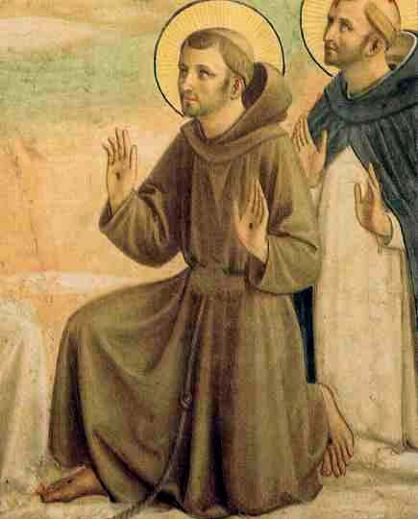
It befell on a time that the Abbot of the Monastery of Saint Justin met St. Francis. Beholding him, the devout Abbot with all speed alighted from his horse, that he might both do reverence unto the man of God and hold some converse with him concerning his soul’s welfare. At length, their sweet conference over, the Abbot, as he departed, humbly besought that prayers should be offered on his behalf. St. Francis replied: “I will pray for you with goodwill.” Accordingly, when the Abbot had departed a little space, the faithful Francis spake unto his companion: “Tarry for me awhile. Brother, for I am minded to pay the debt that I have promised.” While he was praying, on a sudden the Abbot felt in his spirit an unwonted glow and a sweetness up until now unknown, and that he was carried out of himself in an ecstasy, and absorbed in God. LM10,5
On another time, a devout woman of noble birth came to unfold her grief unto St. Francis and to ask a remedy. Now she had a right cruel husband, from whom she suffered opposition in the service of Christ, wherefore she besought St. Francis that he would pray for him that God would deign to soften his heart with His own mercy. Hearing this, Francis said unto her, “Go in peace, and confidently await from your husband the comfort that he shall speedily afford you.” And he added: “Say unto him from God and from me that now is the day of mercy, hereafter that of justice.” When he had blessed her, the woman returned, found her husband, and declared what had been spoken. Then the Holy Spirit fell upon him and changed him into a new man, making him in all gentleness reply thus: “Lady, let us serve the Lord, and save our souls.” Then by the persuasions of his devout wife for many years they lived a life of continence, and both on the same day departed unto the Lord. CA 69
Another time, one friar who was molested by a temptation asked St. Francis: "Pray for me, good Father: I am convinced that I will be immediately freed from my temptations if you will deign to pray for me. I am just plagued beyond my strength, and I know you have understood well. " As soon as St. Francis prayed for him and urged, immediately the Friar experienced, free of all the temptations, so much spiritual consolation 2Celano 118.
In the Province of Rome, a very devout and holy friar saw this marvellous vision. A certain friar, a very dear companion of his, having died one night, was buried, in the morning, before the entrance of the, chapter-house; and, on the same day, after dinner, that friar betook himself into a corner of the chapter-house, to pray God and St. Francis devoutly for the soul of that dead friar his companion. And, as he persevered in prayer with supplications and tears, at noon, when all the others were gone away to sleep, he heard a great noise as of one being dragged through the cloister; whereat immediately with great fear he turned his eyes toward the grave of his companion, and saw St. Francis standing there at the entrance of the chapter-house, and behind him a great multitude of friars round about the said grave. He looked beyond, and saw in the midst of the cloister a very great flaming fire, and in the flames was the soul of his companion who was dead.
He looked round the cloister and he saw Jesus Christ walking round the cloister with a great company of angels and of saints. And, while he gazed upon these things and marvelled much, he saw that, when Christ passed before the chapter-house, St. Francis kneeled down with all those friars and tell thus: "I beseech Thee, my dearest Father and Lord, that, through the inestimable charity which you shown to the human race in your incarnation, you may have mercy on the soul of this my friar, who burn in yonder flame"; and Christ answered him never a word but passed on.
And, when He returned, the second time, and passed before the chapter-house, St. Francis again kneeled him down with his friars, as at the first, and besought Him on this wise: "I pray Thee, merciful Father and Lord, through the boundless charity which you showed to the human race when you died upon the wood of the cross, that You may have mercy on the soul of this my friar"; and Christ passed on as before and answered him not. And going round the cloister He returned the third time and passed before the chapter-house, and then St. Francis, kneeling down as before, showed unto Him his hands and his feet and his side and told thus: "I beseech Thee, merciful Father and Lord, by that great pain and great consolation which I endured when Yout set these Stigmata in my flesh, that You mayt have pity on the soul of this my friar that is in that fire of purgatory". No sooner was Christ prayed that third time by St. Francis in the name of his Stigmata, than He forthwith stayed His steps and, looking upon the stigmata, gave ear unto his prayer and told thus: "To thee, Francis, I grant the soul of thy friar".
And in this, of a surety, He willed to honour and confirm the glorious Stigmata of St. Francis, and openly to signify that the souls of his friars, which go to Purgatory, can in no way be more easily delivered from their pains and brought to the glory of Paradise, than by virtue of his Stigmata, according unto the words which Christ told unto St. Francis when He imprinted them upon him. Wherefore, as soon as these words had been spoken, that fire in the cloister vanished, and the dead friar came to St. Francis: and, together with him and with Christ, all that blessed company went up into heaven with their glorious King. For the which cause, this friar his companion, who had prayed for him, was exceeding glad when he saw him delivered from his pains and taken to paradise; and thereafter he told all that vision in order to the other friars, and together with them gave praise and thanks to God. 5th FiorCons.
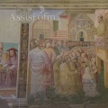
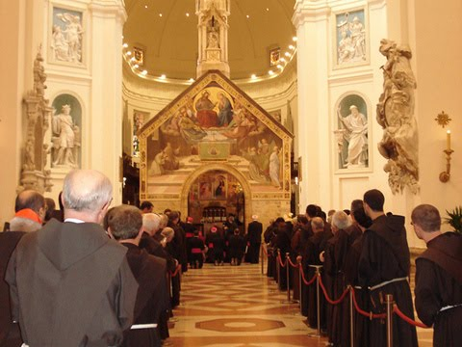
In fact, his request to get the grace of the Indulgence, the Vicar of Christ, Pope Honorius III, on August 2, it is not once again confirms the love and mercy that St. Francis felt towards all: towards those who are live, those who died and those who will come after him? REDEEMED MAN - reconciled with himself, with others and with creation - he is the merciful man and he, he alone knows to praise the author of life, the author of mercy! And the new humanism, to be able to use mercy to others, because it has received from the mercy of God.

Onorato Grassi, in occasione della Presentazione del testo: Francesco d’Assisi e la misericordia de P.Martinelli: hht l’incontro inerente Francesco d’Assisi e la Misericordia tenuto dal mons. Paolo Martinelli e dal prof. Onorato Grassi:tps://youtu
https://zenit.org/articles/saint-francis-and-mercy/

